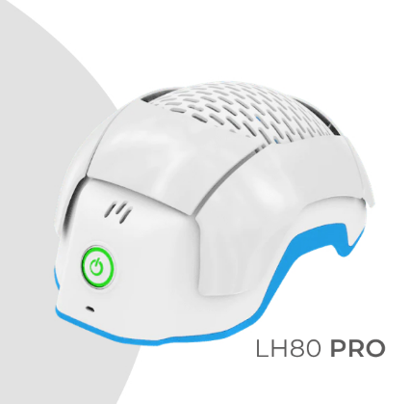

**HAIR GROWTH TECHNOLOGY**

Recommended by hair transplant surgeons, dermatologists and trichologists worldwide.

**LASER PHOTOTHERAPY AND THE THERADOME HELMET**

First discovered in 1965, laser phototherapy is a proven, safe and effective form of hair loss management. The Theradome LH80 PRO is an exciting and unique laser phototherapy helmet, specially designed for both men and women to use at home as a stand alone therapy or in combination with other hair loss treatments. The helmet is manufactured in California, USA and distributed worldwide. It is FDA approved as a clinically effective hair loss treatment with no known side effects. It is used for the treatment of many hair loss conditions, including:

* Male and female pattern hair loss (androgenetic alopecia)
* Telogen effluvium (diffuse excessive hair fall)
* Menopausal and age-related hair thinning
* Post partum hair loss (after childbirth)
* Post chemotherapy
* Following a hair transplant to increase healing, reduce inflammation, promote faster growth and maintain newly transplanted follicles

The Theradome LH80 helmet has the following features:

* lightweight, rechargeable (one charge delivers up to 7 treatments) and cordless/hands free, so you have freedom to move around
* straightforward to use – one button control, battery low indicator, automatic shut off, session timer and treatment counter
* fits all head sizes with foam pads used to improve comfort and fit for smaller heads
* 80 custom made laser diodes which are optimally tuned at a wavelength of 678nm, allowing them to penetrate up to 5mm to optimise stimulation of the hair follicle. This is in contrast to the LEDs or low grade lasers used in other devices which provide therapeutic skin effects but are unable to penetrate to the depth of the hair follicle
* cold lasers and a ventilated design feature at the top of the helmet disperse heat so avoiding the decrease in laser power associated with increased temperature. Theradome generates an increase in heat of less than 1 degree during a treatment session
* a professional strength laser helmet which is technically similar to an in-clinic machine. It has the same number of lasers, wavelength and power. It fits conveniently into your lifestyle at a fraction of the clinical treatment cost and without the time constraints and inconvenience.

**PROVEN BENEFITS**

The helmet: encourages new hair growth; reduces hair loss and excessive hair fall; increase

The Theradome LH80 PRO benefits hair loss sufferers in many ways, including;

* Encouraging new hair growth
* Reducing hair loss
* Increasing hair shaft diameters, improving the hair’s density
* Giving an overall improvement in hair quality, structure and condition
* Can help with inflammation and scalp health
* Increases blood circulation to the hair follicles (vasodilation)
* Stimulates production of growth factors and mitochondria to produce ATP, a source of energy for use within the cells, and improves cellular metabolism and tissue oxygenation
* Boosts keratin production for better hair quality and curl
* Restores miniaturised hair shaft diameter
* Lengthens the anagen (growth) phase of the hair growth cycle
* Reduces inflammation to facilitate healing of damaged cells

**HOW TO USE THE THERADOME HELMET**

Whilst the speed and extent of improvement varies between individuals, 98% of users notice a benefit in 3-6 months and a visible improvement within 12 months. Darker skin colours tend to respond more quickly. Patience and regular use is essential to a successful outcome. Theradome recommend 2 x 20 minute sessions per week. In common with other trichologists, I recommend use every other day, on clean, dry hair if possible, with at least 24 hours between treatments. Whilst vigorous exercise and head movement are not recommended, many everyday tasks such as using your phone or laptop, watching the TV or loading the dishwasher pose no problem.



**EVIDENCE OF SUCCESS - BEFORE AND AFTER**

These before and after images were taken over 4 to 12 months. No hair colouring, hair fibers, hair systems or prescription medications (eg finasteride, minoxidil or PRP injections) were used. These are actual Theradome users and customers. View more at theradome.com.

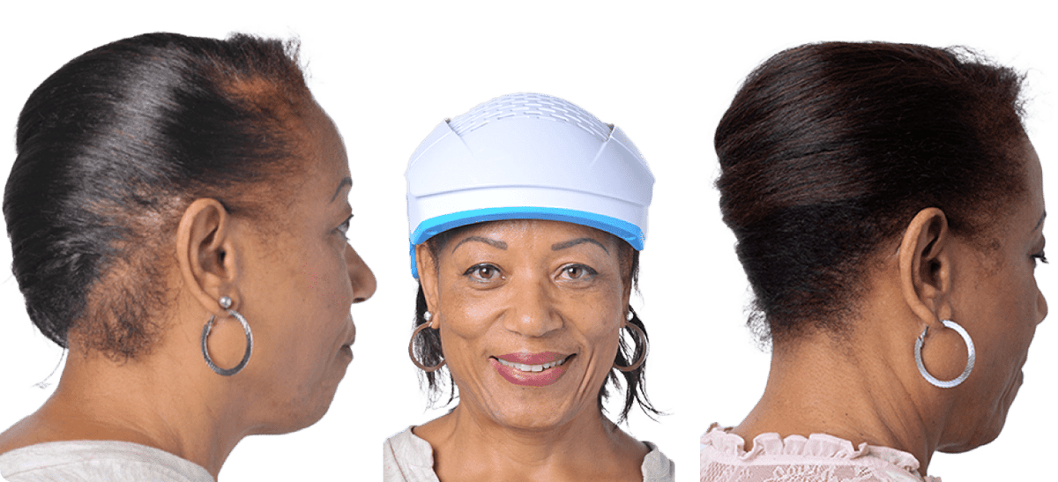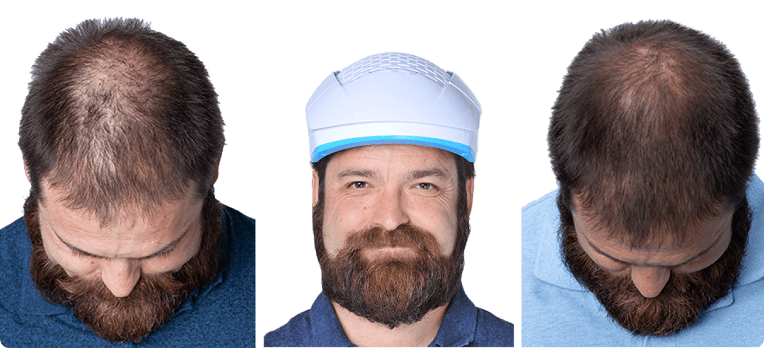

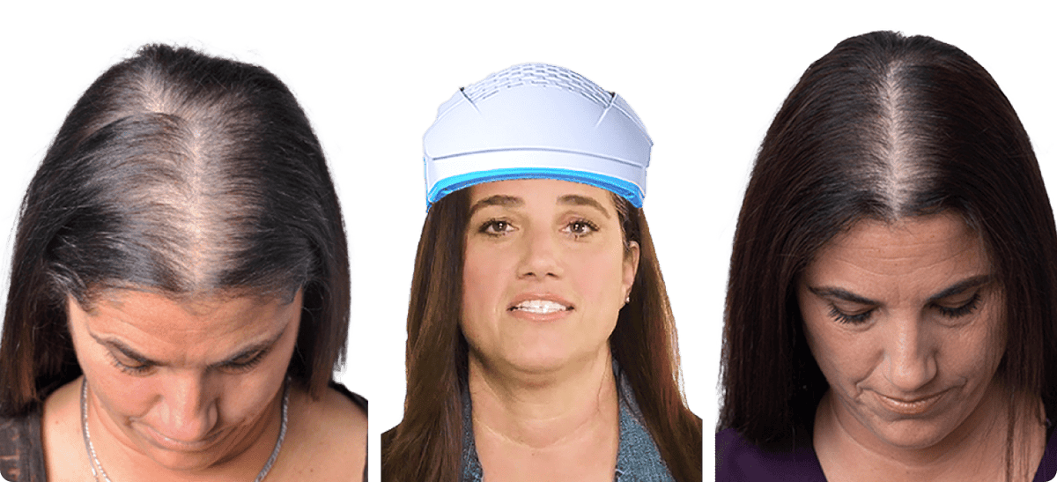

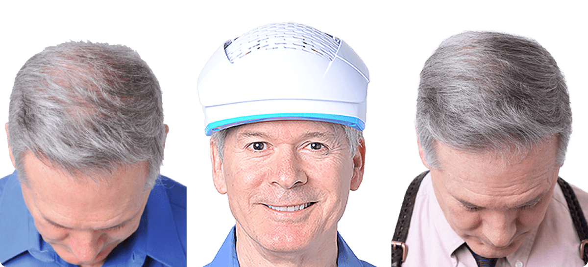

**The best way to buy a Theradome helmet**

My patients usually choose to buy their helmet through me. This enables me to support them with its use and I offer a short free monitoring appointment after 6 months to evaluate effectiveness as well as a discount of £25 off the normal price of £899. Theradome GB (Hair Loss Lasers UK Ltd) is the sole UK importer and distributor of new Theradome Laser Helmets and you can buy direct from them (including on Amazon). They are able to answer any questions you may have before and after your purchase whether you have purchased through me or direct from them. Helmets are also available from Theradome in the USA. I do not recommend this to my patients as it is difficult to get excellent, quick and responsive customer service from so far away. There are also additional costs like VAT, import tax and a broker fee which adds about £250 to the price.